PulseBlasterESR: High Speed Programmable

Pulse Generator / Digital Word Generator

PulseBlasterESRTM is a high-speed, programmable, multi-channel pulse generator in the PCI or Compact-PCI form factor. Based on the versatile PulseBlasterTM processor architecture, PulseBlasterESRTM offers up to 24 independently controlled channels, variable output rates, up to 4096 instruction words, and powerful program-flow features. Currently available clock frequencies are up to 400 MHz.

Key Specifications
- High speed - currently up to 400 MHz clock frequency
- 24 independently controlled output channels (21 for -PRO); TTL 3.3 V (unterminated)
- Four BNC bracket mounted connectors, 50 ohm impedance matched
- Three IDC headers for 24 signal outputs
- Programmable pulse lengths from 2.5 ns (PRO, 400 MHz) to 10 s per instruction
- Sub-1 ns rise/fall times
- 2.5 ns pulse resolution (at 400 MHz)
- 512 or 4096 (-PRO) pulse program instruction words
- Advanced pulse-program flow control: nested loops (8 levels), subroutines
- Software and hardware triggering; up to 10 MHz retriggering frequency
- PCI or c-PCI (PXI) form factor.

Applications
Complex, high-speed, multi-channel pulse, pattern, and word generation. Customers’ applications have included
- Experiment and process control in Electron, Nuclear and Quadrupole Resonances (ESR, NMR, NQR)
- Mass Spectrometry and related test technologies
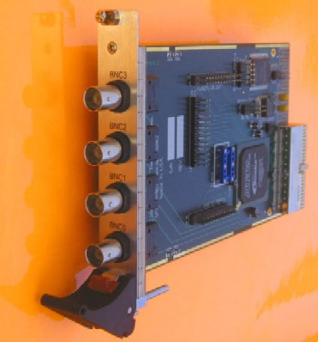
- Ultrasound, radar, medical imaging
Sample Output
- Laser control in advanced communication
- Solid state physics experiments
- Nanomagnetism and spintronics applications
- Robotics and process synchronization
- Data bus emulation
- General laboratory use.
(24 channels)

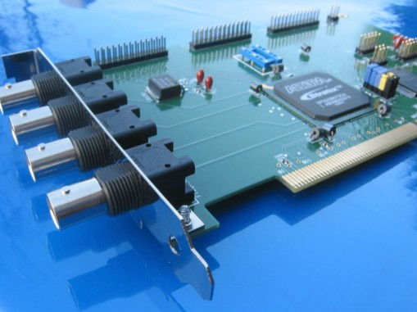
Free Software Support

- Application Programming Interface (API) in C, for Windows and Linux
- Example programs in C
- Interfaces and examples - LabView, Matlab, IGOR-PRO, SpecMan, Visual Basic, Custom GUI.

Hardware Warranty

- Standard warranty - two years
- Longer warranty periods available
- Money-back guarantee – 30 days.

Models and Ordering Information

PBESR-XX and PBESR-PRO-XX

XX – Clock frequency, in MHz. Standard values are 200, 250, 300, 333, and 400 MHz. Other values upon request.


Sample Part Number: PBESR-PRO-400 (400 MHz clock frequency, 2.5 ns shortest pulse, 4k memory depth).

