

PulseBlasterESR-PRO™
(PCI Boards SP4B and SP18A)

300, 400, and 500 MHz

Owner’s Manual

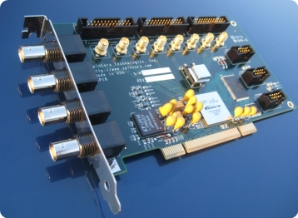
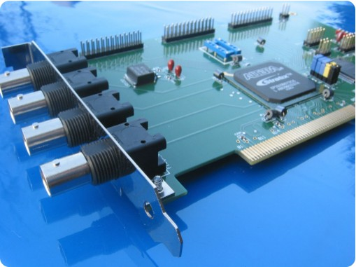

SpinCore Technologies, Inc.
http://www.spincore.com

Congratulations and thank you for choosing a design from SpinCore Technologies, Inc.
We appreciate your business!
At SpinCore we aim to fully support the needs of our customers. If you are in need of assistance, please contact us and we will strive to provide the necessary support.

© 2000-2012 SpinCore Technologies, Inc. All rights reserved.
SpinCore Technologies, Inc. reserves the right to make changes to the product(s) or information herein without notice. PulseBlasterESR™, PulseBlaster™, SpinCore, and the SpinCore Technologies, Inc. logos are trademarks of SpinCore Technologies, Inc. All other trademarks are the property of their respective owners.

SpinCore Technologies, Inc. makes every effort to verify the correct operation of the equipment. This equipment version is not intended for use in a system in which the failure of a SpinCore device will threaten the safety of equipment or person(s).

Table of Contents
I. Introduction 5
Product Overview 5
Board Architecture 6
Block Diagram 6
Output Signals 6
Timing Characteristics 7
Instruction Set 7
External triggering 7
Summary 7
Specifications 8
TTL Specifications 8
Pulse Parameters (using 500 MHz clock frequency) 8
Pulse Program Control Flow (Common) 8
II. Installation 9
Installing the PulseBlasterESR-PRO 9
III. Programming the PulseBlasterESR-PRO 10
The PulseBlaster Interpreter 10
LabVIEW Extensions 11
C/C++ Programming 12
Using C Functions to Program the PulseBlasterESR-PRO 14
Example Use of C Functions 16
IV. Connecting to the PulseBlasterESR-PRO 17
Connector Information 17
BNC Headers 17
IDC Headers 18
HWTrig/Reset Header for SP4B 20
Connector Locations for the SP18A board 21
SMA Headers 21
HW_Trig/Reset Header for SP18A 21
Appendix I: Controlling the PulseBlasterESR-PRO with SpinAPI 23
Instruction Set Architecture 23
Machine-Word Definition 23
Breakdown of 80-bit Instruction Word 23
About SpinAPI 27
Related Products and Accessories 28
Contact Information 29
Document Information 29

I. Introduction

Product Overview
The PulseBlasterESR-PRO™ is a high-speed, intelligent pulse/pattern generator designed for outputting precisely timed TTL patterns. The intelligence of the PulseBlasterESR-PRO comes from an embedded microprogrammed controller core nicknamed the PulseBlaster™. The controller is able to execute instructions that allow it to control program flow much like a general purpose microcontroller. The speed of the PulseBlasterESR-PRO comes from a maximum available clock of 500 MHz.
The PulseBlasterESR-PRO’s microprogrammed controller core is different from the general-purpose microcontroller in that it does not contain an arithmetic logic unit (ALU) – instead, the PulseBlaster processor contains a set of highly optimized instructions developed specifically for timing and control applications. A unique and distinguishing feature of the PulseBlasterESR-PRO processor is that the execution time for instructions is user programmable. This feature makes the PulseBlasterESR-PRO processor capable of executing complex timing patterns at greatly varying update rates, ranging from nanoseconds to years, with a constant setting accuracy of just one clock period.

Board Architecture

Block Diagram
Figure 1 presents the general architecture of the PulseBlasterESR-PRO system. The major building blocks are the SRAM memory, the PulseBlaster™ core, the integrated bus controller (IBC), the counter, and the output buffers. The entire logic design, including the SRAM memory and output buffers, is contained on a single silicon chip, making it a System-on-a-Chip design. User control to the system is provided through the integrated bus controller (IBC) over the PCI bus.

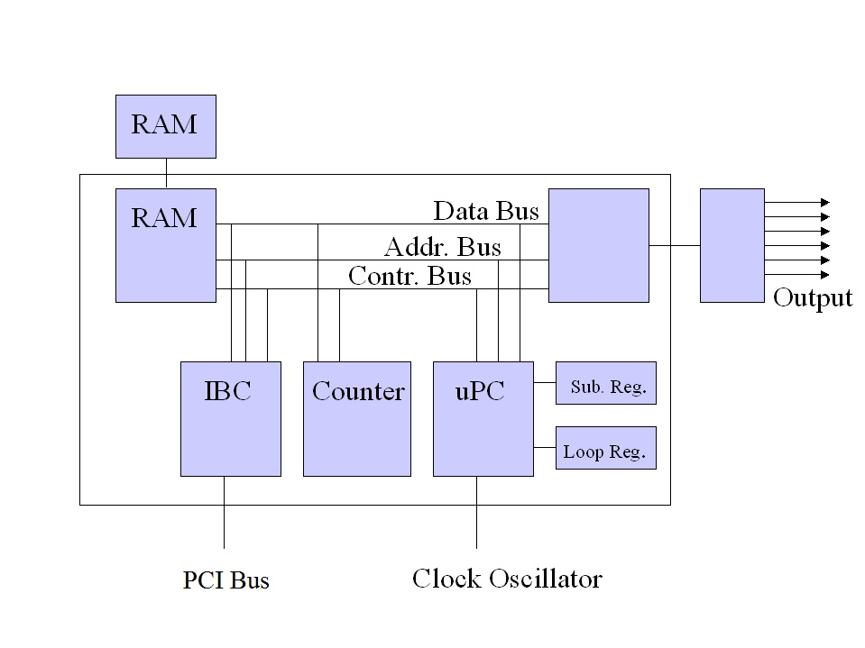Figure 1: PulseBlasterESR-PRO Board Architecture. The clock oscillator signal is derived from an on-chip PLL circuit typically using a 50 MHz on-board reference clock.

Output Signals
The PulseBlasterESR-PRO allows for 21 digital output signal lines. All 21 signal lines are routed to two sets of 26-pin IDC on-board connectors. The first four output bits are also routed to four bracket mounted BNC connectors. The output signals are impedance matched to 50 ohm.
The 21 individually controlled digital output bits comply with the TTL-levels’ standard, and are capable of delivering ±25 mA per bit/channel. If more output current is necessary, the individual bits/channels can be driven in parallel.

Timing Characteristics
The PulseBlaster™ core's timing controller accepts an external (on-board) crystal oscillator of 50 MHz. The input frequency is internally multiplied. The PulseBlasterESR-PRO is available with 3 different internal clock frequencies: 300 MHz, 400 MHz, and 500 MHz. The innovative architecture of the timing controller allows the processing of either simple timing instructions (with delays of up to 2³² or 4,294,967,296 clock cycles), or double-length timing instructions (up to 2⁵² clock cycles long – over 100 days at 500 MHz!). Regardless of the type of timing instruction, the timing resolution remains constant for any delay – just one clock period (e.g., 2 ns at 500 MHz).
The PulseBlaster core-timing controller has a very short minimum instruction time – only five clock periods. This translates to a 10 ns machine instruction time at 500 MHz. The PulseBlasterESR-PRO is also capable of generating pulses on all outputs of lengths down to one clock cycle. For more information on this feature, please see the Short Pulse Feature section in Appendix I.

Instruction Set
The PulseBlaster™ core features a set of instructions for creating highly flexible pulse program flow control. The micro-programmed controller allows for programs to include branches, subroutines, and loops at up to 8 nested levels – all this to assist the user in creating dense pulse programs that cycle through repetitious events, especially useful in numerous multidimensional spectroscopy and imaging applications.

External triggering
PulseBlasterESR-PRO can be triggered and/or reset externally via dedicated hardware lines. The two separate lines combine the convenience of triggering (e.g., in cardiac gating) with the safety of the "stop/reset" line. The required control signals are “active low” (or short to ground).

Summary
PulseBlasterESR-PRO is a versatile, high-performance pulse/pattern TTL signal generator operating at speeds of up to 500 MHz and capable of generating pulses ranging from 2 ns to 8.59 s per instruction at intervals ranging from 10 ns to 8.59 s per instruction (using a 500 MHz clock signal). It can accommodate pulse programs with highly flexible control commands of up to 8192 instruction words. Its high-current output logic bits are independently controlled with an unterminated output voltage of 3.3 V.

Specifications

TTL Specifications
- 21 individually controlled digital output lines (LVTTL levels, 3.3 V logical “one” unterminated)
- 4 bracket mounted BNC connectors, impedance matched to 50 ohm
- variable pulses/delays for every TTL line
- 25 mA output current per TTL line

Pulse Parameters (using 500 MHz clock frequency)
- 2 ns shortest pulse
- 10 ns shortest interval¹
- 8.59 s longest pulse/interval
- 2 ns pulse/interval resolution
- 4096 instructions
- External triggering and reset – 3.3V LVTTL levels

Pulse Program Control Flow (Common)
- Loops, nested 8 levels deep
- 20 bit loop counters (max. 1,048,576 repetitions)
- Subroutines, nested 8 levels deep
- Wait for trigger – 8 clock cycle latency (16ns at 500 MHz), adjustable to 0.89 seconds in duration
- 15 MHz max. re-triggering frequency

II. Installation

Installing the PulseBlasterESR-PRO
To install the board you must complete the following three steps:
- Download and install the latest SpinAPI software package on your computer. SpinAPI is available at: http://www.spincore.com/support/spinapi/
- SpinAPI is a custom Application Programming Interface package developed by SpinCore Technologies, Inc. SpinAPI is designed to be used only with SpinCore Technologies, Inc. products. SpinAPI can be utilized using C/C++, or graphically (described in Section III).
- SpinAPI contains device drivers and the PulseBlaster Interpreter program (described in Section III). A shortcut to the location of these files is created automatically in the Windows Start Menu at “Start > Programs > SpinCore”. See the “readme.txt” file in this location for more information.
- There is an additional package available to download and install that offers example programs to run on your PulseBlasterESR-PRO. The installer for these examples can be found at http://spincore.com/CD/spinapi_examples/Installers/. However, if only some example programs are needed then they can be individually downloaded from http://spincore.com/CD/spinapi_examples/Individual%20Files/.
- Shut down the computer, insert the PulseBlasterESR-PRO card into an available PCI slot and fasten the PC bracket securely with a screw.
- Turn on the computer and follow the installation prompts.
We recommend running the example programs when you first receive a PulseBlaster device to verify that your device is functional. If the example programs were installed using the installer provided by SpinCore then the example programs for the PulseBlasterESR-PRO can be found in the Windows Start Menu at “Start > Programs > SpinCore > Examples”. This will open the Examples directory; the file PulseBlasterESR-PRO will hold all of the examples for the PulseBlasterESR-PRO. If the files were downloaded individually then the test programs will be found in the user defined directory.

III. Programming the PulseBlasterESR-PRO

The PulseBlaster Interpreter
The PulseBlasterESR-PRO can be programmed using PulseBlaster Interpreter, which is a free programming utility provided by SpinCore for writing pulse programs. This easy-to-use editor allows you to create, edit, save, and run your pulse sequence. Figure 2 below shows the PulseBlaster Interpreter being used with an example program.
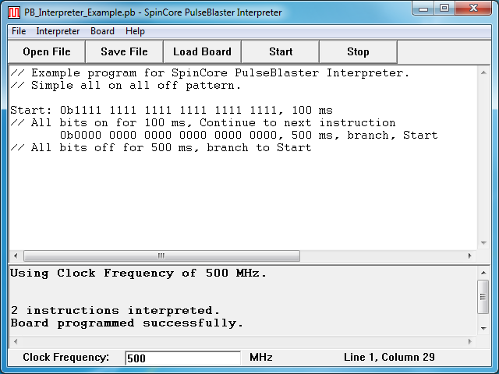
Figure 2: Graphical Interface of PulseBlaster Interpreter. The example shown creates a pulse that toggles all TTL bits on for 100 ms, then off for 500 ms, and repeats.
The PulseBlaster Interpreter is available as part of the SpinCore driver suite, and will be automatically installed during the setup process (setup process is described in Section II. Installation). For convenience, a shortcut to the PulseBlaster Interpreter will be added to your desktop. For more information on programming using the PulseBlaster Interpreter, see the manual located at http://www.spincore.com/support/SPBI/Doc/

LabVIEW Extensions
The SpinCore PulseBlaster LabVIEW Extensions (PBLV) provide the ability to program and control the functionality of PulseBlaster boards using the simple National Instruments (NI) LabVIEW graphical programming interface. The package contains basic subVIs that can be used to include PulseBlaster interaction from your own LabVIEW programs, as well as some complete example VIs. Additionally, all of the examples are available as stand-alone applications to control.
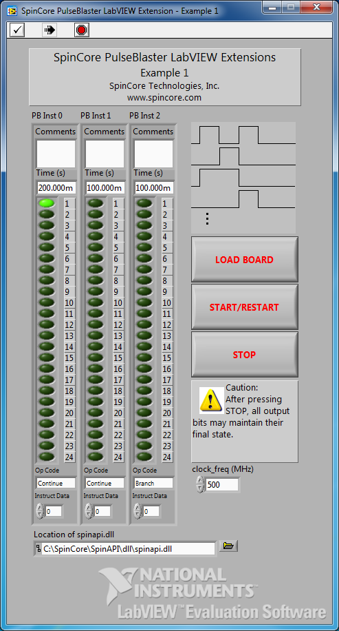
Figure 3: Example of PulseBlaster LabVIEW Extensions User Interface.

There are two versions of the LabVIEW extensions available free of charge on our website. The first is for those who do not have LabVIEW or who are not familiar with LabVIEW programming. This option is a stand-alone GUI (see Figure 3 above) that comes in executable form and utilizes the LabVIEW runtime environment. The second is for those who have LabVIEW and would like to make a custom interface for the PulseBlasterESR-PRO. For more information and downloads please visit: http://www.spincore.com/support/PBLV/

C/C++ Programming
The most dynamic and flexible way to program the PulseBlasterESR-PRO board is with C/C++ using the SpinAPI package. The GUI based approaches to programming the board are designed for simplicity so they can be used by someone with no programming experience.
While GUI's are easier to use, coding in C/C++ allows you to better utilize the various features of the board and in some cases it may be easier to copy and paste lines of code than to make 100 instructions on a GUI. With the pre-configured compiler on our website, changing one of our example programs and recompiling the executable file for use with your PulseBlasterESR-PRO board is as easy as clicking “Rebuild All” (see Figure 4 below). You can get this pre-configured compiler on our website at: http://www.spincore.com/support/spinapi/.

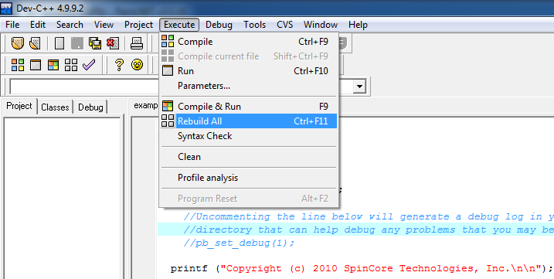
Figure 4: Compiling a C program to run the PulseBlasterESR-PRO board is easy!

Making changes to an example program requires understanding of only a few lines of code. The following C code example generates a 50% duty cycle square wave with a 400.0 ms period.
1: pb_init(); /*Initialize communication with the board*/
2: pb_core_clock (CLOCK); /*Set the internal clock frequency value – this
3: will be either 300 MHz, 400 MHz, or 500 MHz
4: depending on your product */
5:
6: /*Start programming the Pulse Program*/
7: pb_start_programming (PULSE_PROGRAM);
8: start=pb_inst(ON|0x01, CONTINUE, 0, 200.0*ms); /*Bit 0 on, 200ms*/
9: pb_inst(0x00, BRANCH, start, 200.0*ms);/*All bits off, 200ms*/
10: pb_stop_programming();
11:
12: pb_start(); /*Start the board executing*/
13: pb_close(); /*Close the communication with the board*/

A breakdown of the previous C code segment is as follows:

- Line 1: Initialize communication with the selected board. This must be called before any other functions that communicate with the board.
- Line 2: Set the internal block clock frequency (in MHz.) This must be called to insure proper timings in the pulse program.
- Lines 7-10: Programs the board's pulse program memory.
- pb_start_programming(PULSE_PROGRAM) must be called before using the pb_inst(..) function.
- Instruction 1: Turn on bit 0 for 200.0 ms then continue to the next instruction. The address of this instruction is stored in the “start” variable.
- Note: If the output is high for more than 5 clock cycles, it is necessary to turn off the short pulse feature by settings bits 21-23 of the flag bits to “111.” This can be easily accomplished by using the C-macro “ON” defined in “spinapi.h.”
- Instruction 2: All bits off for 200.0 ms, then branch to “start.”
- pb_stop_programming() must be called before calling any other SpinAPI functions.
- Line 12: Start the board executing the Pulse Program.
- Line 13: Close communication with the board (Pulse Program execution will continue.)

Using C Functions to Program the PulseBlasterESR-PRO
A series of functions have been written to control the board and facilitate the construction of pulse program instructions. It should be noted that the pb_inst C function accepts any delay value greater than 17 ns. Since the clock period is 3.3 ns for a 300 MHz clock, values which are not integer multiples of the clock will be rounded to the closest integer multiple.
In order to use these functions, the DLL (spinapi.dll), the library file (libspinapi.a for mingw, spinapilibgcc for borland, and spinapi.lib for msvc), the header file (spinapi.h), must be in the working directory of your C compiler.
int pb_init();

Initializes the PulseBlasterESR-PRO board. Needs to be called before calling any functions using the device. Returns a negative number on an error or 0 on success.

int pb_close();

Releases the PulseBlasterESR-PRO board. Needs to be called as last command in pulse program. Returns a negative number on an error or 0 on success.

void pb_core_clock(double clock_freq);

Used to set the clock frequency of the board. The variable clock_frequency is specified in MHz when no units are entered. Valid units are MHz, kHz, and Hz. The default clock value is 400 MHz. You only need to call this function if you are not using a 400 board.

int pb_start_programming(int device);

Used to initialize the system to receive programming information. It accepts a parameter referencing the target for the instructions. The only valid value for device is PULSE_PROGRAM, It returns a 0 on success or a negative number on an error.

int pb_inst(int flags, int inst, int inst_data, double length);

Used to send one instruction of the pulse program. Should only be called after start_programming(PULSE_PROGRAM) has been called. It returns a negative number on an error, or the instruction number upon success. If the function returns –99, an invalid parameter was passed to the function. Instructions are numbered starting at 0.

int flags – determines state of each TTL output bit. Valid values are 0x000000 to 0x1FFFFF. For example, 0x000010 would correspond to bit 4 being on, and all other bits being off.

int inst – determines which type of instruction is to be executed. Please see Table 3 for details.

int inst_data – data to be used with the previous inst field. Please see Table 3 for details.

double length – duration of this pulse program instruction, specified in ns.

The largest value for the delay field of the pb_inst is 640ns. For longer delays, use the LONG_DELAY instruction (see Table 3). The maximum value for the data field of the LONG_DELAY is 1048576. Even longer delays can be achieved using the LONG_DELAY instruction inside of a loop.

int pb_stop_programming();

Used to tell that programming the board is complete. Board execution cannot start until this command is received. It returns a 0 on success or a negative number on an error.

int pb_start();

Once board has been programmed, this instruction will start execution of pulse program. It returns a 0 on success or a negative number on an error.

int pb_stop();

Stop the Pulse Program execution. TTL outputs will either remain in their last state or return to zero, depending on the firmware version of the board. It returns a 0 on success or a negative number on an error.

There are currently six example C programs available with the SpinAPI package in the PBESR-PRO directory.

Example Use of C Functions
#include <stdio.h>
#include <stdlib.h>

#define PBESRPRO
#include "spinapi.h"

#define CLOCK 400.0 // PulseBlaster core clock rate

int main (int argc, char **argv)
{
int start;

printf ("Copyright (c) 2010 SpinCore Technologies, Inc.\n\n");
printf("Using SpinAPI library version %s\n", pb_get_version());

if (pb_init () != 0) {
printf ("Error initializing board: %s\n", pb_get_error());
system("pause");
}

// Tell driver what clock frequency the board uses
pb_core_clock(CLOCK);

// Prepare the board to receive pulse program instructions
pb_start_programming(PULSE_PROGRAM);

// Instruction 0 - Continue to instruction 1 in 20ns. The lower 4 bits
// (all BNC connectors) will be driving high. For PBESR-PRO boards,
// or-ing THREE_PERIOD with the flags causes a 3 period short
// pulse to be used.
start = pb_inst(THREE_PERIOD | 0xF, CONTINUE, 0, 20.0 * ns);

// Instruction 1 - Continue to instruction 2 in 40ns
// The BNC1-3 will be driving high the entire 40ns.
pb_inst(ON | 0xE, CONTINUE, 0, 40.0 * ns);

// Instruction 2 - Branch to "start" (Instruction 0) in 40ns
// Outputs are off
pb_inst(0, BRANCH, start, 40.0 * ns);

pb_stop_programming(); // Finished sending instructions

pb_reset();
pb_start(); // Trigger the pulse program

// End communication with PulseBlasterESR-PRO board. The pulse program
// will continue to run even after this is called.
pb_close();

return 0;
}

IV. Connecting to the PulseBlasterESR-PRO

Connector Information
There are three main connector banks on the PulseBlasterESR-PRO board: the BNC headers, the IDC headers, and the Trigger/Reset header. Additionally, the SP18A offers SMA headers. The SP18A board is shown on the first page of this manual, right picture.

Figure 5: Connector Locations for SP4B. The SP4B board is shown on the first page of this manual, left picture.
BNC3
BNC2
BNC1
BNC0
Flag0...11 Out
Flag12..23 Out
Flag24..35 Out
HWTRIG/RESET

BNC Headers
The four BNC headers provide access to the least significant four bits of the flag word. Bit 3 is connected to the output farthest from the PCI connector, and Bit 0 is connected to the connector closest to the PCI connector.
If using a high input impedance oscilloscope to monitor the PulseBlasterESR-PRO's output via the BNC connectors, place a resistor that matches the characteristic impedance of the transmission line in parallel with the coaxial transmission line at the oscilloscope input. (e.g., a 50 Ω resistor with a 50 Ω transmission line, see Figures 6 and 7 below). When using an oscilloscope with an adjustable bandwidth, set the bandwidth to as large as possible. Failure to do so may yield inaccurate readouts on the oscilloscope.

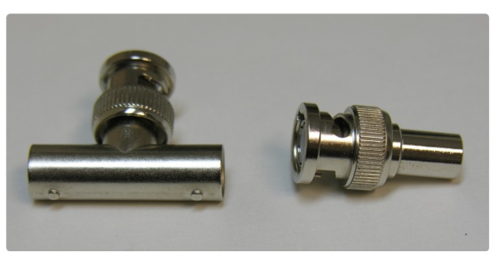Figure 6: Left: BNC T-Adapter and Right: BNC 50 Ohm resistor.

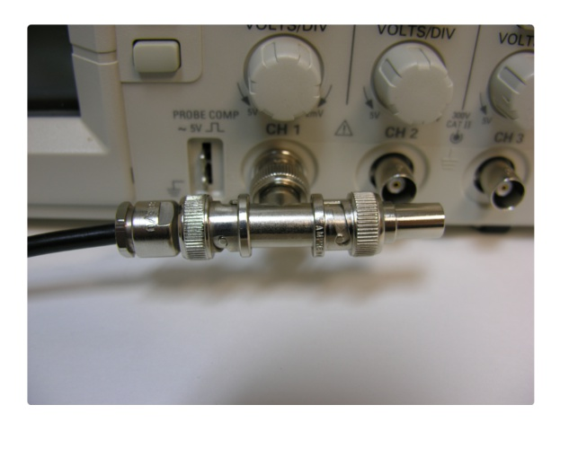

Figure 7: BNC T-Adapter on the oscilloscope with coaxial transmission line connected on the left and BNC 50 Ohm resistor connected on the right, to terminate the line.

IDC Headers
Figure 8: IDC header Pin-Out.
There are three IDC headers on the PulseBlasterESR-PRO, which provide access to all digital 21 outputs as well as the status bits. These are labeled on the board as Flag0..11 Out, Flag12..23 Out and Flag24..35 Out. On each IDC header, the top row of pins (14-26) are grounds, and the signals are carried on pins 1-13.
Each pin on an IDC header corresponds to a bit in the flag field of an instruction. The association between bits and pins are shown in the table below.

Pin Assignments
Pin# | Flag0..11 | Flag12..23 | Flag24..35
1 | Bit 0 | Bit 12 | Stopped
2 | Bit 1 | Bit 13 | Reset
3 | Bit 2 | Bit 14 | Running
4 | Bit 3 | Bit 15 | Waiting
5 | Bit 4 | Bit 16 | Unused
6 | Bit 5 | Bit 17 | Unused
7 | Bit 6 | Bit 18 | Unused
8 | Bit 7 | Bit 19 | Unused
9 | Bit 8 | Bit 20 | Unused
10 | Bit 9 | Bit 21 | Unused
11 | Bit 10 | Bit 22 | Unused
12 | Bit 11 | Bit 23 | Unused
13 | Unused | Unused | Unused
14-26 | Ground | Ground | Ground

Table 1: IDC connector pin outs.
The Status pins are set or cleared based on the state of the PulseBlasterESR-PRO. The pins are located on IDC header Flag24...35, from pin 1 to pin 4. The status pins are defined as follows:
- Stopped – Driven high when the PulseBlasterESR-PRO has encountered a STOP Opcode during program execution and has entered a stopped state.
- Reset – Driven low when the PulseBlasterESR-PRO is in a RESET state. The device must be reprogrammed before code execution can begin again.
- Running – Driven high when the PulseBlasterESR-PRO is executing a program. The pin is driven low when the PulseBlasterESR-PRO enters either a reset or idle state.
- Waiting – Driven high when the PulseBlasterESR-PRO has encountered a WAIT Opcode, and is waiting for the next trigger (either hardware or software) to resume operation.
Note that it is also possible to read the status bits via software by using the pb_read_status() function. Please see http://www.spincore.com/CD/spinapi/spinapi_reference/ for details.

HWTrig/Reset Header for SP4B

Figure 9: HWTrig/Reset Header Pin-Out(SP4B).
4 | 3
2 | 1

This is an input connector, for hardware triggering (HW_Trigger) and hardware resetting (HW_Reset). Pins 1 and 2 are the reset and trigger inputs, respectively, and pins 3 and 4 are grounds.

HW_Trigger (active-low) is pulled high by default using a 10 kΩ resistor, and pin 2 is active (pin 4 = GND). When a falling edge is detected (e.g., when shorting pins 2-4) and the program is idle, code execution is triggered. If the program is idle due to a WAIT Op Code, then the HW_Trigger will cause the program to continue to the next instruction. If the program is idle due to a STOP Op Code or a HW_Reset signal, then the HW_Trigger starts execution from the beginning of the program. When using the STOP Op Code, a HW_Reset or software reset (pb_reset()) needs to be applied prior to the HW_Trigger.
NOTE: The PulseBlasterESR-PRO requires a 3.3 V TTL input signal for HW_Trigger. A signal that is more than 3.3 V or less than 0 V will damage the device.

HW_Reset (active-low) is pulled high by default using a 10 kΩ resistor, and pin 1 is active (pin 3 = GND). It can be used to halt the execution of a program by pulling it low (e.g., by shorting pins 1-3). When the signal is pulled low during the execution of a program, the controller resets itself back to the beginning of the program. Program execution can be resumed by either a software start command (pb_start()) or by a hardware trigger.
NOTE: The PulseBlasterESR-PRO requires a 3.3 V TTL input signal for HW_Trigger. A signal that is more than 3.3 V or less than 0 V will damage the device.

Connector Locations for the SP18A board

Figure 10: Connector Locations (SP18A).
BNC3
BNC2
BNC1
BNC0
Flag0...11 Out
Flag12..23 Out
Flag24..35 Out
SMA0
SMA1
SMA2
SMA3
SMA4
SMA5
SMA6
SMA7
HW_TRIG/RESET

The SP18A board has identical connectors to the SP4B board, but includes SMA headers for easy access to more flag outputs and a modified HW_Trig/Reset header.

SMA Headers

The eight SMA headers provide access to the flag bits 4 through 11. SMA0, the header closest to the BNC headers, corresponds to flag bit 4. SMA7, the header furthest from the BNC header, corresponds to flag bit 11.

HW_Trig/Reset Header for SP18A

Figure 11: HW_Trig/Reset Header Pin-Out(SP18A).
9 | 7 | 5 | 3 | 1
10 | 8 | 6 | 4 | 2

This is an input connector for hardware triggering (HW_Trigger) and resetting (HW_Reset). Pins 8 and 10 are the HW_Reset and HW_Trigger pins, respectively. Pins 2, 4, and 6 are reserved. Pins 1,3,5,7, and 9 are all grounds.

HW_Trigger (active-low) is pulled high by default using a 10 kΩ resistor, and pin 10 is active (pin 9 = GND). When a falling edge is detected (e.g., when shorting pins 10-9) and the program is idle, code execution is triggered. If the program is idle due to a WAIT Op Code, then the HW_Trigger will cause the program to continue to the next instruction. If the program is idle due to a STOP Op Code or a HW_Reset signal, then the HW_Trigger starts execution from the beginning of the program. When using the STOP Op Code, a HW_Reset or software reset (pb_reset()) needs to be applied prior to the HW_Trigger.
NOTE: The PulseBlasterESR-PRO requires a 3.3 V TTL input signal for HW_Trigger. A signal that is more than 3.3 V or less than 0 V will damage the device.

HW_Reset (active-low) is pulled high by default using a 10 kΩ resistor, and pin 8 is active (pin 7 = GND). It can be used to halt the execution of a program by pulling it low (e.g., by shorting pins 8-7). When the signal is pulled low during the execution of a program, the controller resets itself back to the beginning of the program. Program execution can be resumed by either a software start command (pb_start()) or by a hardware trigger.
NOTE: The PulseBlasterESR-PRO requires a 3.3 V TTL input signal for HW_Trigger. A signal that is more than 3.3 V or less than 0 V will damage the device.

Appendix I: Controlling the PulseBlasterESR-PRO with SpinAPI

Instruction Set Architecture

Machine-Word Definition
The PulseBlasterESR-PRO pulse timing and control processor implements an 80-bit wide Very Long Instruction Word (VLIW) architecture. The VLIW is partitioned into fields dedicated to specific purposes, and every VLIW is viewed as a single instruction by the microcontroller. The maximum number of instructions that can be loaded onto the PulseBlasterESR-PRO is 4096. The execution time of instructions can be varied and is under (self) control by one of the fields of the instruction word – the shortest being five clock cycles and the longest being 2^28 clock cycles.

Breakdown of 80-bit Instruction Word
All instructions have the same format and bit length, and all bit fields need to be filled. Table 2 shows the fields and bit definitions of the 80-bit instruction word.
Bit Definitions for the 80-bit Instruction Word (VLIW)
Output/Control Word | Data Field | OP Code | Delay Count
24 bits | 20 bits | 4 bits | 32 bits
Table 2: Partitioning of the 80-bit Instruction Word (VLIW).
The 80-bit VLIW is broken up into 4 sections:

- Output Pattern and Control Word: 24 bits.

- Data Field: 20 bits.

- OP Code: 4 bits.

- Delay Count: 32 bits

All bits above the eighth bit must be programmed with zeros.

Output Pattern and Control Word

Table 3 shows the output pattern and control bit assignments of the 24-bit output/control word.
Bit # |  | Bit # | Function
23 | Controls Pulse Length for BNC connectors | 11 | Output Connector labeled Flag0..11, Pin 12
22 | Controls Pulse Length for BNC connectors | 10 | Output Connector labeled Flag0..11, Pin 11
21 | Controls Pulse Length for BNC connectors | 9 | Output Connector labeled Flag0..11, Pin 10
20 | Output Connector labeled Flag12..23, Pin 9 | 8 | Output Connector labeled Flag0..11, Pin 9
19 | Output Connector labeled Flag12..23, Pin 8 | 7 | Output Connector labeled Flag0..11, Pin 8
18 | Output Connector labeled Flag12..23, Pin 7 | 6 | Output Connector labeled Flag0..11, Pin 7
17 | Output Connector labeled Flag12..23, Pin 6 | 5 | Output Connector labeled Flag0..11, Pin 6
16 | Output Connector labeled Flag12..23, Pin 5 | 4 | Output Connector labeled Flag0..11, Pin 5
15 | Output Connector labeled Flag12..23, Pin 4 | 3 | Output Connector labeled Flag0..11, Pin 4
14 | Output Connector labeled Flag12..23, Pin 3 | 2 | Output Connector labeled Flag0..11, Pin 3
13 | Output Connector labeled Flag12..23, Pin 2 | 1 | Output Connector labeled Flag0..11, Pin 2
12 | Output Connector labeled Flag12..23, Pin 1 | 0 | Output Connector labeled Flag0..11, Pin 1

Table 3: Output Pattern and Control Word Bits.

When the bit corresponding to an IDC output connector is one, the voltage will be high for the duration of the instruction. If the bit is zero, the voltage will be low low for the duration of the instruction.

Short Pulse Feature

The Short Pulse feature utilizes the upper three bits of the instruction flag output bits (bits 21 to 23) to control the number of clock cycles output flags are enabled. This allows for short pulses down to a single clock cycle during the instruction period. Note that all flags are affected by the short pulse feature. The following table provides information on using the short pulse feature.

SpinAPI Define | Bits 21-23 | Clock periods | Pulse Length at 500 MHz (ns)
- | 000 | - | Always Low
ONE_PERIOD | 001 | 1 | 2
TWO_PERIOD | 010 | 2 | 4
THREE_PERIOD | 011 | 3 | 6
FOUR_PERIOD | 100 | 4 | 8
FIVE_PERIOD | 101 | 5 | 10
ON | 111 | - | No Short Pulse

Table 4: Short Pulse Feature Characteristics.
When bits 21-23 are zero, the output flags remain low for the duration of the instruction. When bits 23-21 are from “000” to “101,”the programmed flag values will be outputted for the specified number of clock cycles. To disable the short pulse feature, bits 21 to 23 must be set to “111.”
Figure 12 gives an example of the Short Pulse feature. The example uses a 3 period duration. This example only shows 4 flags, but all flags will be affected.

Figure 12: Example of the Short Pulse Feature. This example uses a 3 period duration. This example displays the output of 4 flags, but all flags are affected by the Short Pulse feature. Timing is done using a 500.0 MHz Clock.
Instruction: pb_inst (THREE_PERIOD | 0xD, CONTINUE, 0, 10.0 * ns);
Clock Cycle 1
Clock Cycle 2
Clock Cycle 3
Clock Cycle 4
Clock Cycle 5
Flag 0
Flag 1
Flag 2
Flag 3
Minimum Instruction Length (5 Clock Cycles)
2.0 ns
4.0 ns
6.0 ns
8.0 ns
10.0 ns

NOTE: The short pulse functionality is firmware-dependent. Please inquire with SpinCore Technologies for upgrades or details. For firmware 17-11, a four clock cycle short pulse requires a minimum six clock cycle instruction length.

Data Field and Op Code
Please refer to the following table for information on the available instructions and their associated data field argument.

Op Code # | Inst | Inst_data | Function
0 | CONTINUE | Ignored | Program execution continues to next instruction. See note (1) following this table.
1 | STOP | Ignored | Stop execution of program. Aborts the operation of the micro-controller with no control of output states (all TTL values remain from previous instruction). Recommended that prior to the STOP op-code a short interval (minimum six clock cycles) be added to set the output states as desired.
2 | LOOP | Number of desired loops. This value must be greater than or equal to 1. | Specify beginning of a loop. Execution continues to next instruction. Data used to specify number of loops
3 | END_LOOP | Address of beginning of loop | Specify end of a loop. Execution returns to begging of loop and decrements loop counter.
4 | JSR | Address of first subroutine instruction | Program execution jumps to beginning of a subroutine. See Note (2).
5 | RTS | Ignored | Program execution returns to instruction after JSR was called. See Note (2).
6 | BRANCH | Address of next instruction | Program execution continues at specified instruction
7 | LONG_DELAY | Number of desired loops. This value must be greater than or equal to 2. | For long interval instructions. Data field specifies a multiplier of the delay field. Execution continues to next instruction. See Note (2).
8 | WAIT | Ignored | Program execution stops and waits for software or hardware trigger. Execution continues to next instruction after receipt of trigger. The latency is equal to the delay value entered in the WAIT instruction line plus a fixed delay of 6 clock cycles.
- For instructions longer than 640 ns please use a LONG_DELAY instruction.
- For PulseBlasterESR-PRO-500 design 17-11, instructions with JSR, RTS and LONG_DELAY op-codes, require a minimum instruction length of at least 6 clock-cycles (12.0 ns).

Table 5: Op Code and Data Field Description.

Delay Count
The value of the Delay Count field (a 32-bit value) determines how long the current instruction should be executed. The allowed minimum value of this field is 0x00000002 and the allowed maximum is 0x000000FF. The timing controller has a fixed delay of three clock cycles and the value that one enters into the Delay Count field should account for this inherent delay. (NOTE: the pb_inst() family of functions in SpinAPI and the PulseBlaster Interpreter automatically account for this delay.)

About SpinAPI
SpinAPI is a control library which allows programs to be written that can communicate with the PulseBlasterESR-PRO board. The most straightforward way to interface with this library is with a C/C++ program, and the API definitions are described in this context. However, virtually all programming languages and software environments (including software such as LabView and MATLAB) provide mechanisms for accessing the functionality of SpinAPI.
Please see the example programs for examples of how to use SpinAPI. If the programs have not been installed, then information to installing and finding them can be found in the “Installing the PulseBlasterESR-PRO” section. Reference documents for the API are available online at:
http://www.spincore.com/CD/spinapi/spinapi_reference/
http://www.spincore.com/support/spinapi/SpinAPI_Main.shtml

Related Products and Accessories

- Oven Controlled Clock Oscillator (sub-ppm stability) Figure 13. For ordering information contact SpinCore at ηττπ://ωωω.σπινχορε.χομ/χονταχτ.σητμλ.

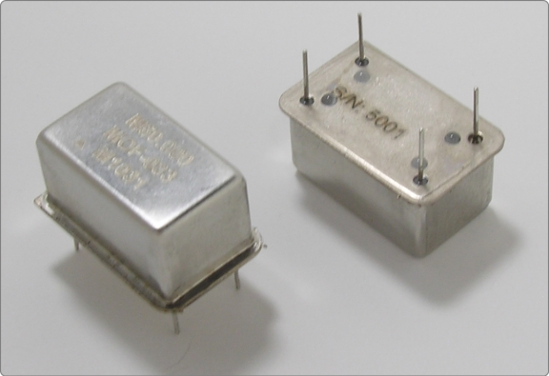
Figure 13: An Oven Controlled Clock Oscillator (or OCXO) with sub-ppm frequency stability is available for the PulseBlaster upon request.
- SMA-BNC Adapter Board Figure 14 - This adapter board is an easy solution to provide access to four additional output signals from the back panel of your computer. SMA-SMA or SMA-IDC cables are available upon request. For ordering information contact SpinCore at ηττπ://ωωω.σπινχορε.χομ/χονταχτ.σητμλ.

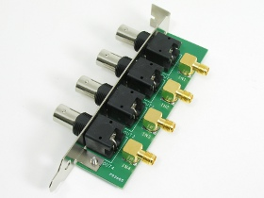
Figure 14: SMA-BNC Adapter Board is available for the SP18A and SP4B boards to access additional flag bits.

- SpinCore TTL Line Driver Figure 15 - A USB-powered device with four input channels and 8 output lines. Each output line is equipped with current driving capabilities to insure TTL voltage level over 50 Ohm loads. The SpinCore TTL Line Driver is the perfect tool to accompany any TTL device. For ordering information contact SpinCore at ηττπ://ωωω.σπινχορε.χομ/χονταχτ.σητμλ.

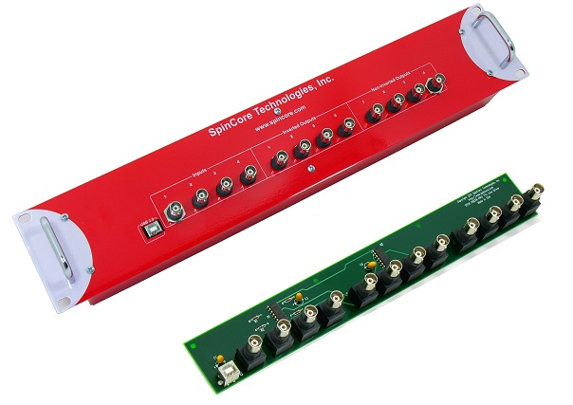
Figure 15: TTL Line Driver assures TTL levels over 50 Ohm loads.
- If you require a custom design, custom interface cables, or other custom features, please inquire with SpinCore Technologies through our contact form, which is available at ηττπ://ωωω.σπινχορε.χομ/χονταχτ.σητμλ.

Contact Information

SpinCore Technologies, Inc.
4631 NW 53rd Avenue, SUITE 103
Gainesville, FL 32653
USA

Telephone (USA): 352-271-7383
Fax (USA): 352-371-8679
Website: http://www.spincore.com
Web Contact Form: http://spincore.com/contact.shtml

Document Information

Revision history available at SpinCore.

NOTE: For PulseBlasterESR-PRO-500 design 17-11, instructions with JSR, RTS and LONG_DELAY op-codes, require a minimum instruction time of at least 6 clock-cycles (12.0 ns). For PulseBlasterESR-PRO-400 design 9-18, the minimum instruction time is 7 clock-cycles (17.5 ns).
These functions and library files have been generated and tested with MinGW (www.mingw.com), Borland 5.5 (www.borland.com), MS Visual Studio 2003 (msdn.microsoft.com) compilers.

